14.2.2 Editors - Movie Clip Editor - Tool shelf - Mask Mode
Detailed Table of content 1
Masking preface 2
S-Curves 2
Mask tab - Mask tools panel 3

Detailed Table of content

3.5 - Movie Clip Editor
Detailed Table of content 1
Masking preface 2
S-Curves 2
Mask tab - Mask tools panel 3
Spline 3
Delete 3
Toggle Cyclic 3
Switch Direction 3
Set Handle Type 3
Last Operator Set Handle Type 3
Type 3
Clear Feather Weight 3
Parenting 4
Parent 4
Clear 4
Animation 4
Insert Key 4
Clear Key 4
Reset Feather Animation 4
Re Key Shape Points 4

Masking preface

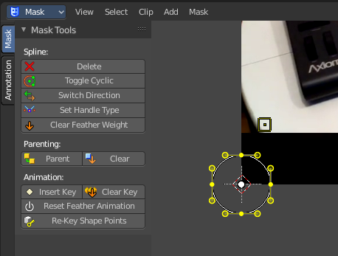
Masks have many purposes. They can be used in a motion tracking workflow to mask out, or influence a particular object in the footage. They can be used for manual rotoscoping to pull a particular object out of the footage. Or as a rough matte for green screen keying. This is done in the Node editor in compositing mode by a mask node.
Masks are independent from a particular image of movie clip. And so they can just as well be used for creating motion graphics or other effects in the compositor.
Masks are defined by splines. Means you work with splines, and you have a bunch of spline tools available.

S-Curves

The curve type used for creating mask splines is almost a Bezier curve. But there are some differences. Smooth edges of the mask are defined by feathering. These are called S-Curves.
Besides the handles, every control point also has points that define the feather between the current point and the next point on the spline. Each feather point is stored in UV space, where U means position across spline segment, and V means distance between main spline and feather points.
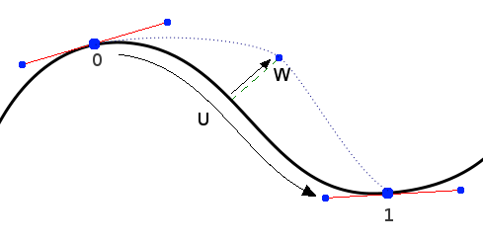
This allows for deforming the main spline in almost any way, and the feather will be updated automatically to reflect that change.
For example if there is just rotation of the spline, feather would stay completely unchanged. If one point’s feather is moved, the other feathers will be automatically stretched uniformly along that segment and the overall shape will be almost the same as artists would want it to be.

Mask tab - Mask tools panel

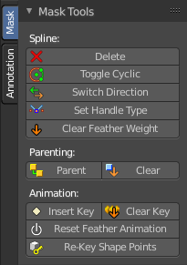
The Mask tools provides you with tools to modify the mask splines. It is divided into three sections. Spline, Parenting and Animation

The splines that you can add have handlers to change their position and size. Parenting allows to make or clear parent relationship. And in the animation section you can animate the spline points.

The Mask Tools panel just appears when a spline exists in the viewport. So either add one from the Add menu. Or hold down ctrl and click to create a freehand spline.

Spline

Delete
Deletes the selected spline point.

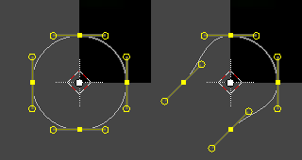
Toggle Cyclic
Toggle between a closed spline and an open spline. A spline can be closed or have two ends.

Switch Direction
Switch direction switches the direction of the spline.

Set Handle Type
Set the type of the spline handles. The different handle types gives you more control about the shape of the spline. The handle type is set in the Last Operator panel.

Last Operator Set Handle Type

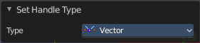
Type
A drop down box where you can again set the handle type.
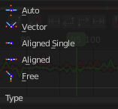

Clear Feather Weight
With Scale feather in the Mask Transform menu you can scale the feather points. With Clear feather weight you can reset this scaling to default.

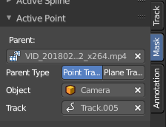
Parenting
You can parent mask points to markers. The relationship of the mask points is shown in the Active Point panel in the sidebar.
Select the desired mask points. Hold down shift and click at the target marker. Then click the Parent button.

Parent
Set the parent for the mask.

Clear
Clear the parent for the mask.

Animation

Insert Key
Inserts a shape key to the selected spline points().

Clear Key
Removes a shape key from the selected spline points().

Reset Feather Animation
Resets feather weights at all selected points animation values.

Re Key Shape Points
Recalculate the animation data on selected points for the selected frames in the dope sheet.

